**RAJSHAHI UNIVERSITY OF ENGINEERING AND TECHNOLOGY**

**Course No:** CSE 3110

**Course Title:** Sessional Based on CSE 3109

**Problem No:** 01

**Problem Name:** Write a program to read two decimal digits whose sum is less than 10 and display their sum on the next line

**Submitted To:**

Sadia Zaman Mishu

Assistant Professor

Computer Science and Engineering

Rajshahi University of Engineering and Technology

**Submitted By:**

Name : Md. Fakhrul Islam

Roll: 1803071

Session: 2018-19

Department : Computer Science and Engineering

Rajshahi University of Engineering and Technology

**Problem No:** 01

**Problem Name:** Write a program to read two decimal digits whose sum is less than 10 and display their sum on the next line.

**Description:**

Assembly language program are converted into machine language instruction by an assembler. Microsoft Macro Assembler is used as an assembler in this program. MOV, ADD, SUB instructions are used to perform the specific task. MOV instruction is used to move a content from memory to memory, variable to memory, constant to memory or variable. Moving element from memory to memory is illegal. The instruction is MOV destination, source. The content is stored in the destination. ADD is used to add two numbers. And the result is stored in the destination. Similarly, SUB is used to subtract two numbers. To input a single character,

MOV AH,1

INT 21H

To output the result

MOV AH,2

INT 21H

To return control to the operating system, MOV AH, 4CH

INT 21H instructions is used. For new line and carriage return, 0AH and 0DH hexadecimal code is used in the assembly language program respectively

**CODE:**

|  |
| --- |
| .MODEL SMALL  .STACK 100H  .CODE  MAIN PROC  MOV AH,1  INT 21H  MOV BL,AL  MOV AH,2  MOV DL,20H  INT 21H  MOV AH,1  INT 21H    ADD BL,AL  SUB BL,48  MOV AH,2  MOV DL,0DH  INT 21H  MOV DL,0AH  INT 21H    MOV DL,BL  INT 21H    MOV AH,4CH  INT 21H    MAIN ENDP  END MAIN |

**OUTPUT:**

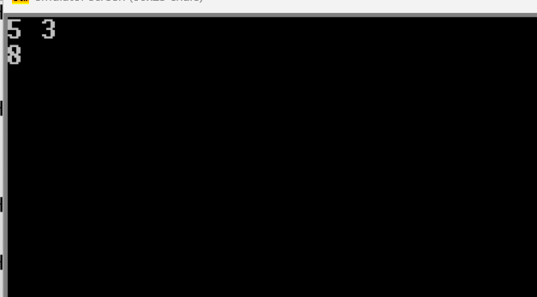

**Conclusion:**

The program can only take a single character input and output a single character. To output more than one character,

MOV AH,9

LEA DX, value

INT 21H

Instructions can be used. After adding, the output will be respective ascii code. To solve this problem, 48 is subtracted from the result which will display the perfect answer.